UNIVERSITY OF ENGINEERING AND TECHNOLOGY

(NAROWAL CAMPUS)

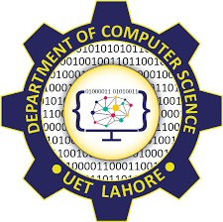

# Object-Oriented Programming Lab Manual

Created by: Muhammad Abdullah

Registration Number: 2022-CS-525

Topics: Unions, Classes and Objects,

Constructor and Destructor, Default Constructor and

Separate interface and implementation

Lab Manual

(Object-Oriented Programming Lab)

* **Task 1:**

Create a union and union variable in a C++ program:

Program:

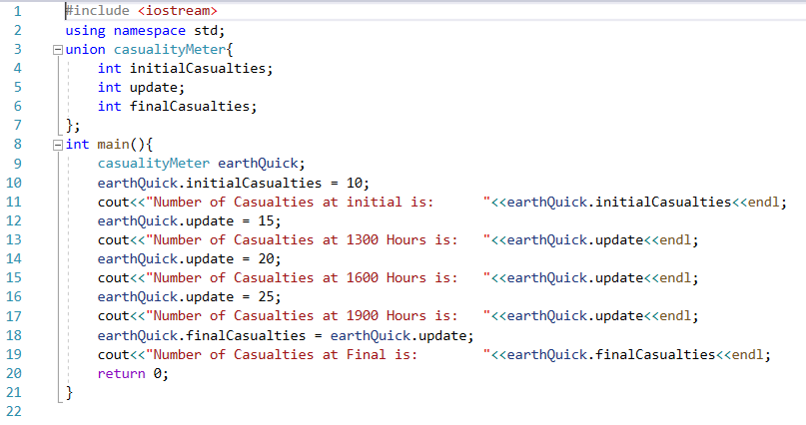

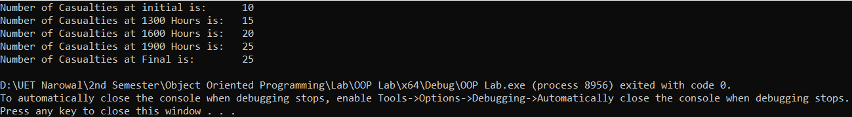Output:

* **Task 2:**

Create a class and its data member and member functions, also create the object of the class in the C++ program

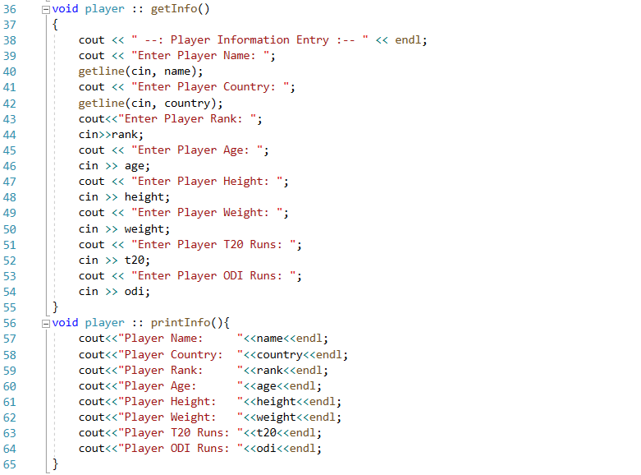Program:

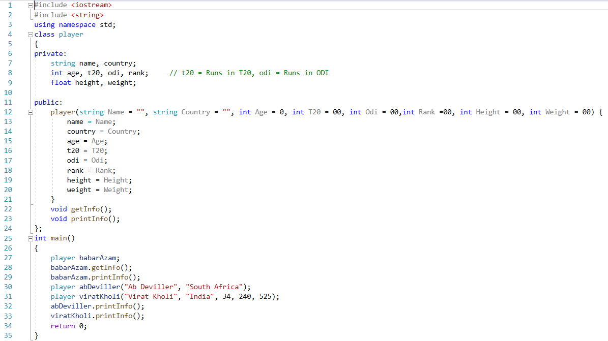

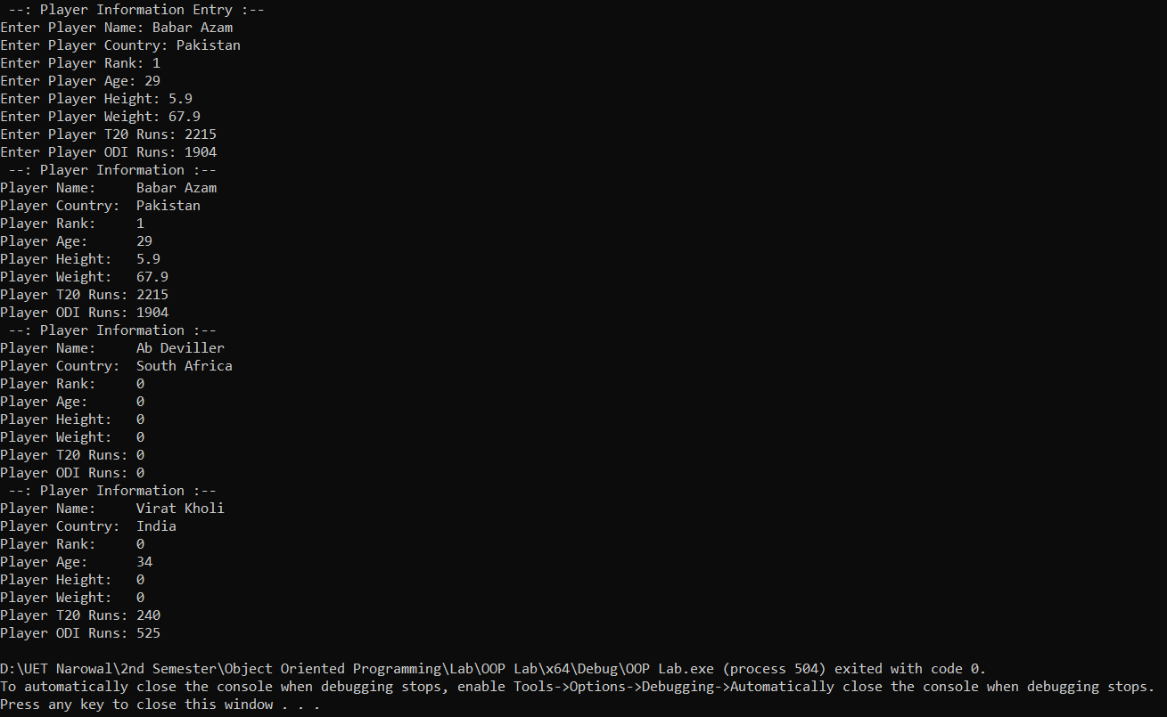Output:

* **Task 3:**

Create a class that contains a constructor and destructor in its definition

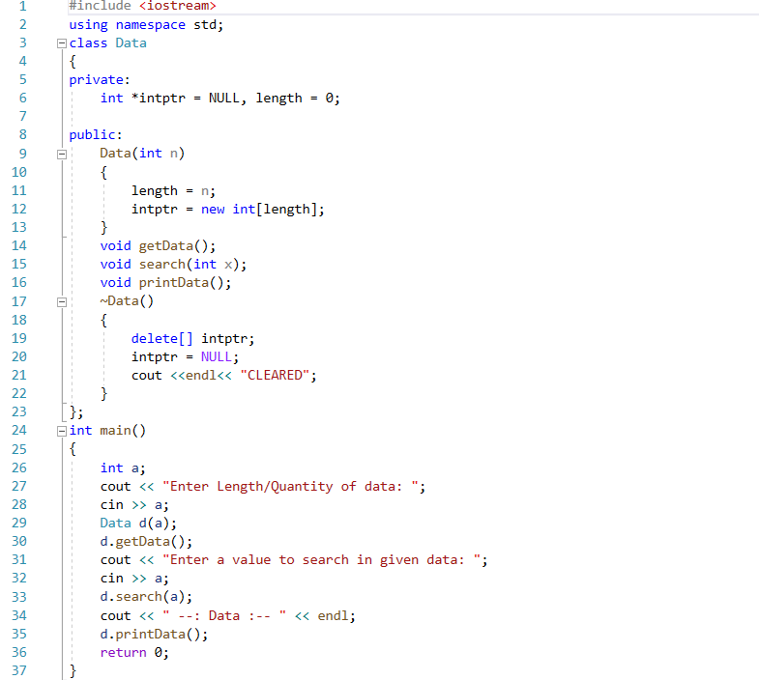Program:

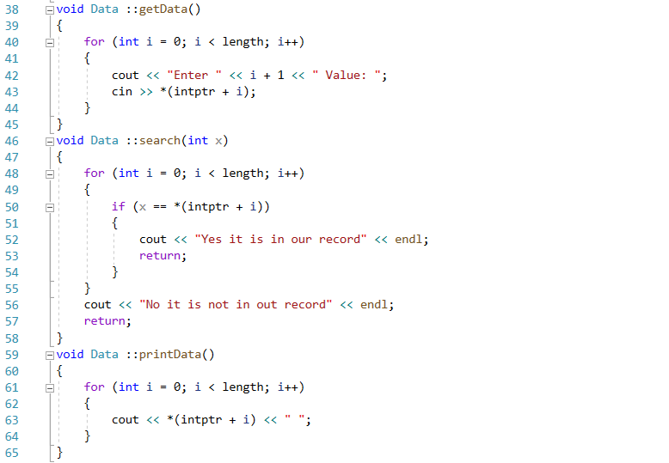

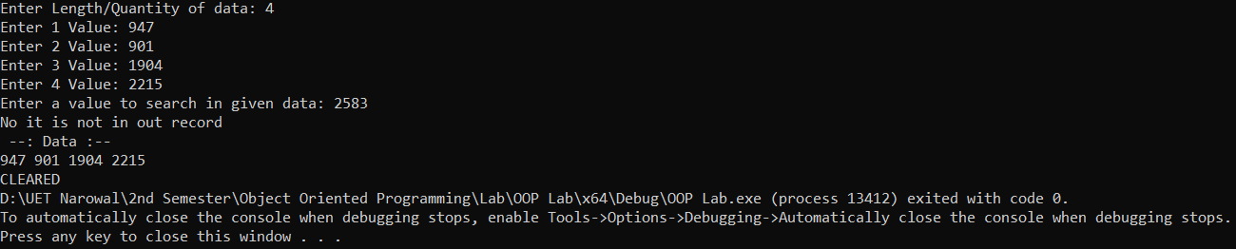Output:

* **Task 4:**

Create a class that contains the default constructor in its definition in the C++ program

Program:

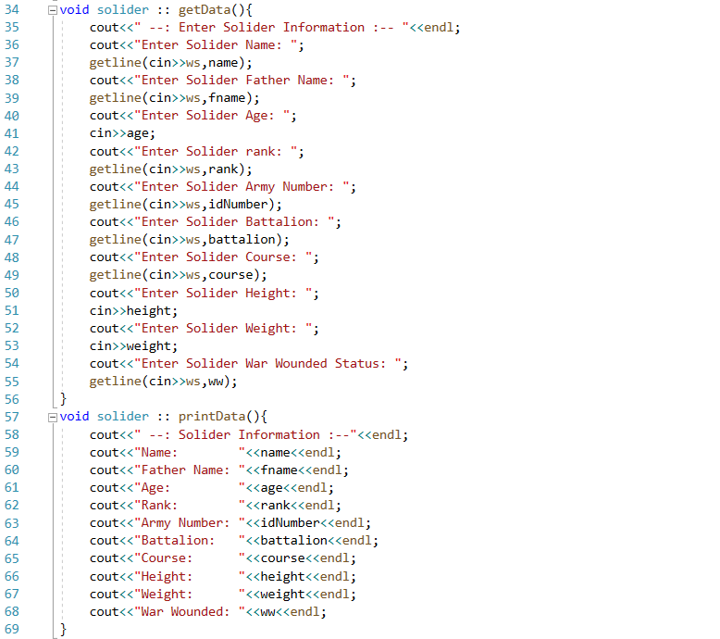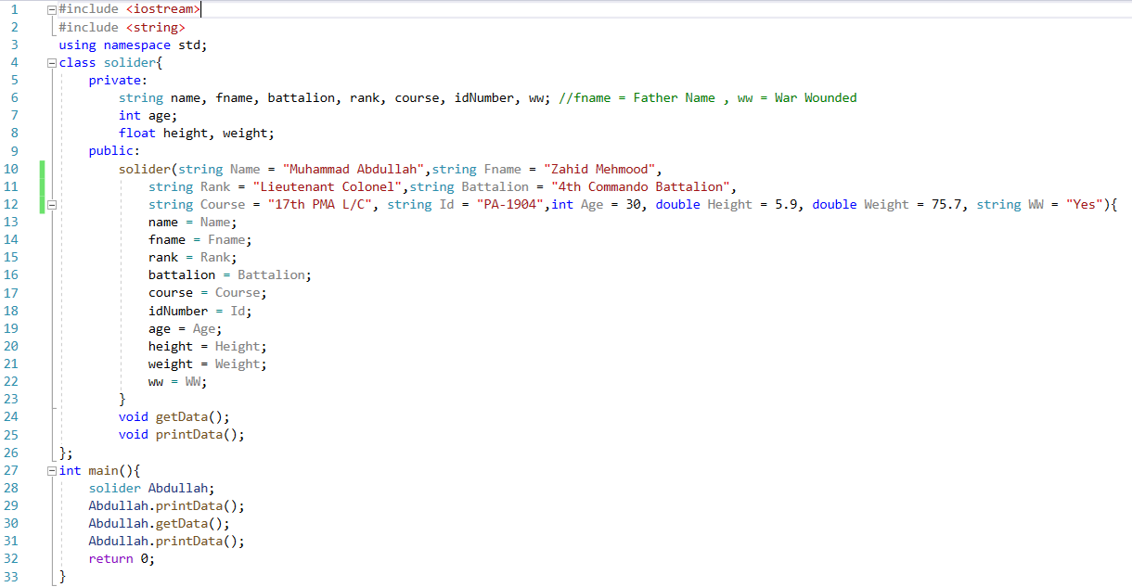

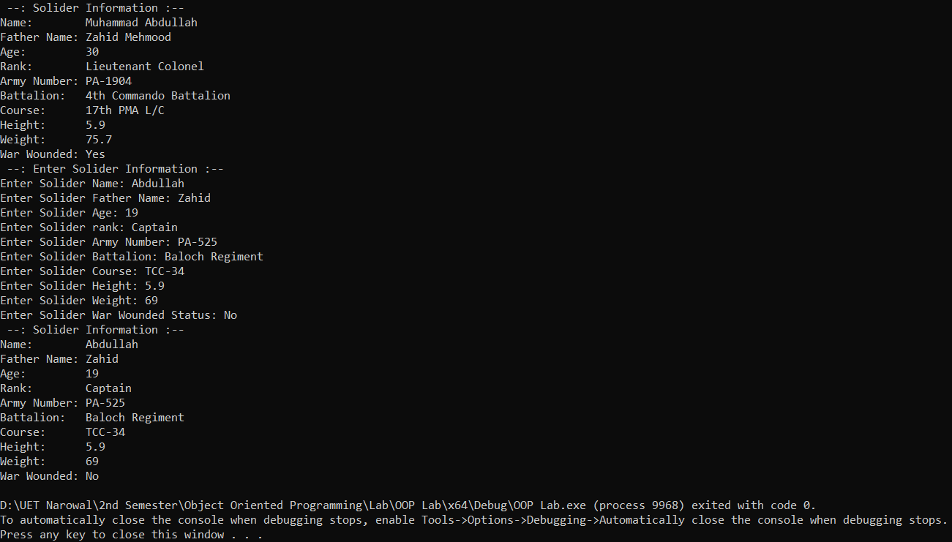Output:

* **Task 5:**

Create a class that has a separate interface and implementation in the C++ program

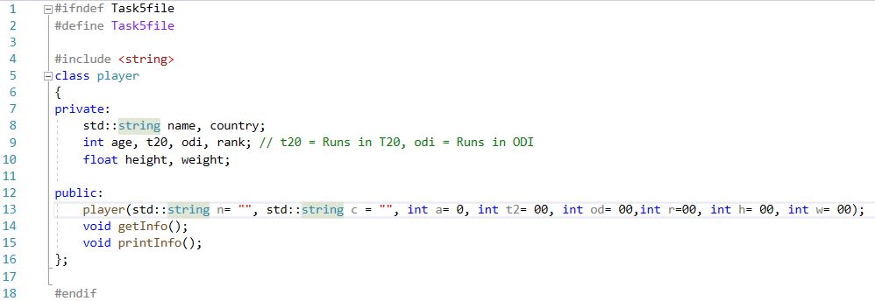Separate File:

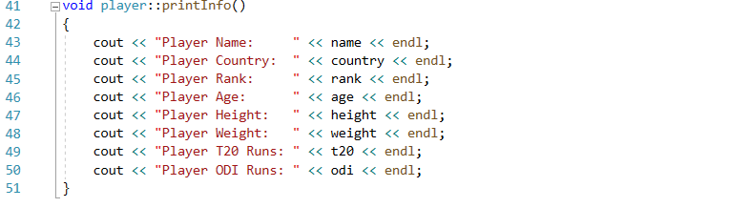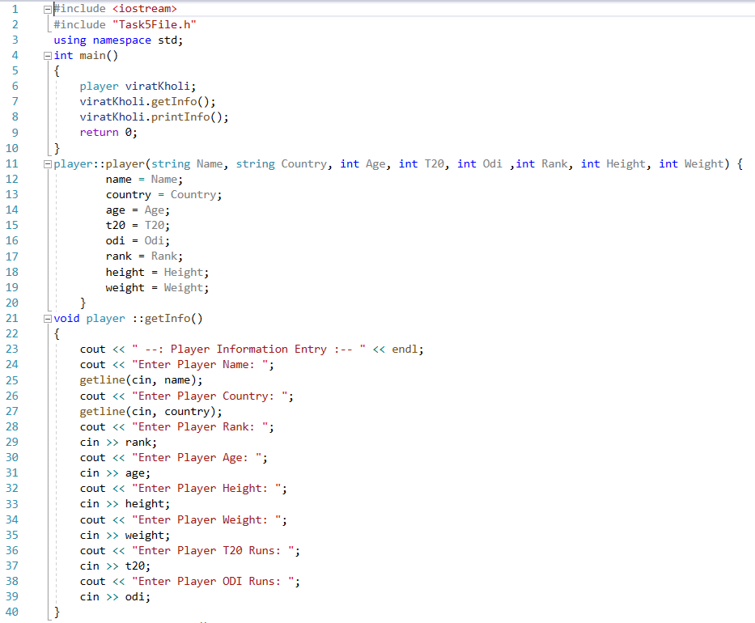Program:

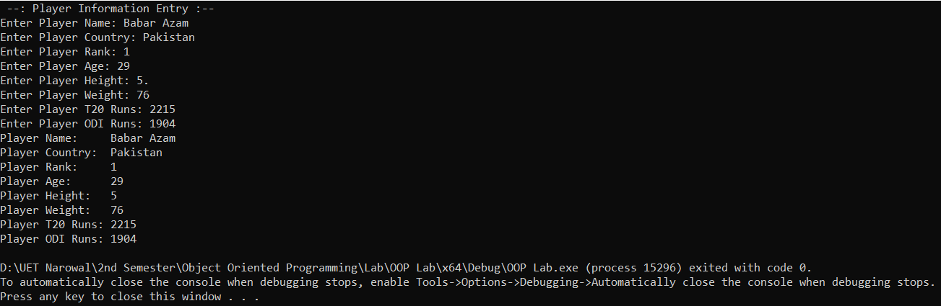Output:

------------------------------------------------------------------------------------------------------------------------------------------